lOMoARcPSD|11310561

ĐỀ CƯƠNG NGHIỆP VỤ NGOẠI THƯƠNG
Nghiệp Vụ Ngoại Thương (Trường Đại học Bách khoa - Đại học Quốc gia Thành phố Hồ Chí Minh)

Scan to open on Studocu
Studocu is not sponsored or endorsed by any college or university
Downloaded by Lê Ph??ng Duy (20122283@st.hcmuaf.edu.vn)
lOMoARcPSD|11310561
Bài 1
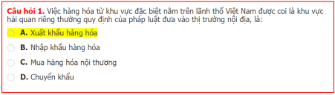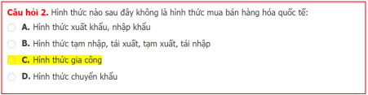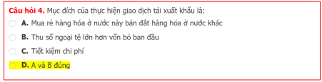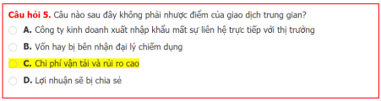
Downloaded by Lê Ph??ng Duy (20122283@st.hcmuaf.edu.vn)
lOMoARcPSD|11310561
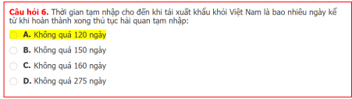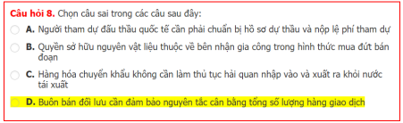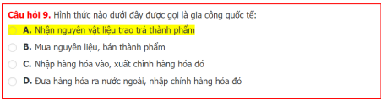
Downloaded by Lê Ph??ng Duy (20122283@st.hcmuaf.edu.vn)
lOMoARcPSD|11310561
Downloaded by Lê Ph??ng Duy (20122283@st.hcmuaf.edu.vn)
lOMoARcPSD|11310561
Bài 2
Downloaded by Lê Ph??ng Duy (20122283@st.hcmuaf.edu.vn)
lOMoARcPSD|11310561
Downloaded by Lê Ph??ng Duy (20122283@st.hcmuaf.edu.vn)
lOMoARcPSD|11310561
Downloaded by Lê Ph??ng Duy (20122283@st.hcmuaf.edu.vn)
lOMoARcPSD|11310561
Downloaded by Lê Ph??ng Duy (20122283@st.hcmuaf.edu.vn)
lOMoARcPSD|11310561
Bài 3
Downloaded by Lê Ph??ng Duy (20122283@st.hcmuaf.edu.vn)
lOMoARcPSD|11310561
Downloaded by Lê Ph??ng Duy (20122283@st.hcmuaf.edu.vn)
lOMoARcPSD|11310561
Downloaded by Lê Ph??ng Duy (20122283@st.hcmuaf.edu.vn)
lOMoARcPSD|11310561
Downloaded by Lê Ph??ng Duy (20122283@st.hcmuaf.edu.vn)
lOMoARcPSD|11310561
Downloaded by Lê Ph??ng Duy (20122283@st.hcmuaf.edu.vn)
lOMoARcPSD|11310561
Downloaded by Lê Ph??ng Duy (20122283@st.hcmuaf.edu.vn)
lOMoARcPSD|11310561
Downloaded by Lê Ph??ng Duy (20122283@st.hcmuaf.edu.vn)
lOMoARcPSD|11310561
Downloaded by Lê Ph??ng Duy (20122283@st.hcmuaf.edu.vn)
lOMoARcPSD|11310561
Downloaded by Lê Ph??ng Duy (20122283@st.hcmuaf.edu.vn)
lOMoARcPSD|11310561
Downloaded by Lê Ph??ng Duy (20122283@st.hcmuaf.edu.vn)
lOMoARcPSD|11310561
Downloaded by Lê Ph??ng Duy (20122283@st.hcmuaf.edu.vn)
lOMoARcPSD|11310561
Downloaded by Lê Ph??ng Duy (20122283@st.hcmuaf.edu.vn)
lOMoARcPSD|11310561
Downloaded by Lê Ph??ng Duy (20122283@st.hcmuaf.edu.vn)
lOMoARcPSD|11310561
Downloaded by Lê Ph??ng Duy (20122283@st.hcmuaf.edu.vn)
lOMoARcPSD|11310561
Downloaded by Lê Ph??ng Duy (20122283@st.hcmuaf.edu.vn)
lOMoARcPSD|11310561
Downloaded by Lê Ph??ng Duy (20122283@st.hcmuaf.edu.vn)
lOMoARcPSD|11310561
Downloaded by Lê Ph??ng Duy (20122283@st.hcmuaf.edu.vn)
lOMoARcPSD|11310561
Downloaded by Lê Ph??ng Duy (20122283@st.hcmuaf.edu.vn)
lOMoARcPSD|11310561
Bài 4
Downloaded by Lê Ph??ng Duy (20122283@st.hcmuaf.edu.vn)
lOMoARcPSD|11310561
Downloaded by Lê Ph??ng Duy (20122283@st.hcmuaf.edu.vn)
lOMoARcPSD|11310561
Downloaded by Lê Ph??ng Duy (20122283@st.hcmuaf.edu.vn)
lOMoARcPSD|11310561
Downloaded by Lê Ph??ng Duy (20122283@st.hcmuaf.edu.vn)
lOMoARcPSD|11310561
Downloaded by Lê Ph??ng Duy (20122283@st.hcmuaf.edu.vn)
lOMoARcPSD|11310561
Downloaded by Lê Ph??ng Duy (20122283@st.hcmuaf.edu.vn)
lOMoARcPSD|11310561
Downloaded by Lê Ph??ng Duy (20122283@st.hcmuaf.edu.vn)
lOMoARcPSD|11310561
Downloaded by Lê Ph??ng Duy (20122283@st.hcmuaf.edu.vn)
lOMoARcPSD|11310561
Downloaded by Lê Ph??ng Duy (20122283@st.hcmuaf.edu.vn)
lOMoARcPSD|11310561
Downloaded by Lê Ph??ng Duy (20122283@st.hcmuaf.edu.vn)
lOMoARcPSD|11310561
Downloaded by Lê Ph??ng Duy (20122283@st.hcmuaf.edu.vn)
lOMoARcPSD|11310561
Downloaded by Lê Ph??ng Duy (20122283@st.hcmuaf.edu.vn)
lOMoARcPSD|11310561
Downloaded by Lê Ph??ng Duy (20122283@st.hcmuaf.edu.vn)
lOMoARcPSD|11310561
Downloaded by Lê Ph??ng Duy (20122283@st.hcmuaf.edu.vn)
lOMoARcPSD|11310561
Downloaded by Lê Ph??ng Duy (20122283@st.hcmuaf.edu.vn)
lOMoARcPSD|11310561
Downloaded by Lê Ph??ng Duy (20122283@st.hcmuaf.edu.vn)
lOMoARcPSD|11310561
Downloaded by Lê Ph??ng Duy (20122283@st.hcmuaf.edu.vn)
lOMoARcPSD|11310561
Downloaded by Lê Ph??ng Duy (20122283@st.hcmuaf.edu.vn)
lOMoARcPSD|11310561
Downloaded by Lê Ph??ng Duy (20122283@st.hcmuaf.edu.vn)
lOMoARcPSD|11310561
Downloaded by Lê Ph??ng Duy (20122283@st.hcmuaf.edu.vn)
lOMoARcPSD|11310561
Downloaded by Lê Ph??ng Duy (20122283@st.hcmuaf.edu.vn)
lOMoARcPSD|11310561
Downloaded by Lê Ph??ng Duy (20122283@st.hcmuaf.edu.vn)
lOMoARcPSD|11310561
Downloaded by Lê Ph??ng Duy (20122283@st.hcmuaf.edu.vn)
lOMoARcPSD|11310561
Downloaded by Lê Ph??ng Duy (20122283@st.hcmuaf.edu.vn)
lOMoARcPSD|11310561
Downloaded by Lê Ph??ng Duy (20122283@st.hcmuaf.edu.vn)
lOMoARcPSD|11310561
Downloaded by Lê Ph??ng Duy (20122283@st.hcmuaf.edu.vn)
lOMoARcPSD|11310561
Downloaded by Lê Ph??ng Duy (20122283@st.hcmuaf.edu.vn)
lOMoARcPSD|11310561
Downloaded by Lê Ph??ng Duy (20122283@st.hcmuaf.edu.vn)
lOMoARcPSD|11310561
Downloaded by Lê Ph??ng Duy (20122283@st.hcmuaf.edu.vn)
lOMoARcPSD|11310561
Downloaded by Lê Ph??ng Duy (20122283@st.hcmuaf.edu.vn)
lOMoARcPSD|11310561
Bài 5
Downloaded by Lê Ph??ng Duy (20122283@st.hcmuaf.edu.vn)
lOMoARcPSD|11310561
Downloaded by Lê Ph??ng Duy (20122283@st.hcmuaf.edu.vn)
lOMoARcPSD|11310561
Downloaded by Lê Ph??ng Duy (20122283@st.hcmuaf.edu.vn)
lOMoARcPSD|11310561
Downloaded by Lê Ph??ng Duy (20122283@st.hcmuaf.edu.vn)
lOMoARcPSD|11310561
Downloaded by Lê Ph??ng Duy (20122283@st.hcmuaf.edu.vn)
lOMoARcPSD|11310561
Downloaded by Lê Ph??ng Duy (20122283@st.hcmuaf.edu.vn)
lOMoARcPSD|11310561
Downloaded by Lê Ph??ng Duy (20122283@st.hcmuaf.edu.vn)
lOMoARcPSD|11310561
Downloaded by Lê Ph??ng Duy (20122283@st.hcmuaf.edu.vn)
lOMoARcPSD|11310561
Downloaded by Lê Ph??ng Duy (20122283@st.hcmuaf.edu.vn)
lOMoARcPSD|11310561
Downloaded by Lê Ph??ng Duy (20122283@st.hcmuaf.edu.vn)
lOMoARcPSD|11310561
Downloaded by Lê Ph??ng Duy (20122283@st.hcmuaf.edu.vn)
lOMoARcPSD|11310561
Downloaded by Lê Ph??ng Duy (20122283@st.hcmuaf.edu.vn)
lOMoARcPSD|11310561
Downloaded by Lê Ph??ng Duy (20122283@st.hcmuaf.edu.vn)

