CÁCH LÀM WRITING TA1-AV1: THAM KHẢO trang 41
PART 2 : ĐỀ BÀI
1 ‘I’m sorry but I’m stuck in a traffic jam. I’ll see you in half an hour.’
2 ‘Thank you for booking the train tickets. I’ll pay you when we meet at the station.’
3 ‘Take the underground to Oxford Street and the Moon café is opposite the station.’
4 ‘Peter wants to come with us in the taxi. Can you call him and tell him where to meet us?’
5 ‘My flight is an hour late. Meet me in the arrivals area at five o’clock.’
BÀI LÀM
1.Sorry. Stuck in traffic. See you in 30 mins.
2 Thanks for booking tickets. Pay you at station.
3 Take underground to Oxford Street. Moon café opposite station.
4 Peter wants to come in taxi. Call and tell him where to meet.
5 Flight 1 hr late. Meet arrivals at 5.
ĐỀ BÀI
You have to work late. Write a text to your friend. Say you will arrive at the bus station an hour later.
2 You are meeting tonight in the city centre. Suggest your friend takes a taxi from the taxi rank outside the train station.
3 You cannot travel with your friend on the underground to the airport. Explain you will travel by bus and meet him/her at the check-in desk.
BÀI LÀM
1 Working late. Arrive bus station 1 hr later.
2 Take taxi outside station to centre.
3 Can’t travel on underground. Will take bus. Meet check-in.

PART 3: VIẾT STORY 120 TỪ theo chủ đề của đề thi
VIẾT THEO TRÌNH TỰ SAU
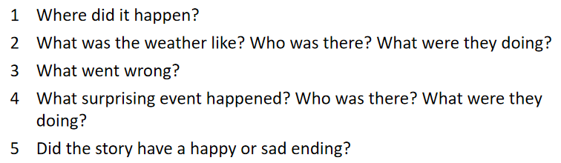
ĐÂY LÀ VÍ DỤ; CÁC EM CHÚ Ý TRONG BÀI PHẢI CÓ CÁC CHỮ MÀU ĐỎ NHÉ


