TRƯỜNG ĐẠI HỌC CÔNG NGHIỆP
ĐỀ KIỂM TRA THƯỜNG KỲ
ANH VĂN 1 & TIẾNG ANH 1
Môn kiểm tra: Listening
Ngày kiểm tra: ....../ ......./ ......
Thời gian làm bài: 35 phút
(Không kể thời gian phát đề)
THÀNH PHỐ HỒ CHÍ MINH
KHOA NGOẠI NGỮ

Họ & Tên: …………………………………………………. MSSV:…………………………

LISTENING TEST (4 parts): 20 questions

Part 1: Questions 1-5
For each question, choose the correct answer.

1. What was the weather like yesterday?
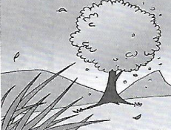
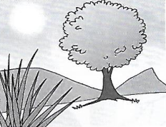
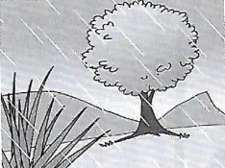

A | B | C

2. What has the man left at home?
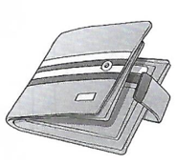



A | B | C

3. What did the girl cook today?
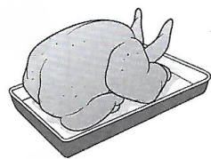
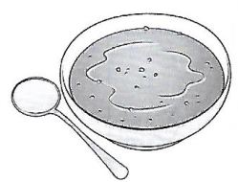
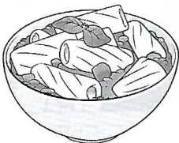

A | B | C

4. Which photo are they looking at?
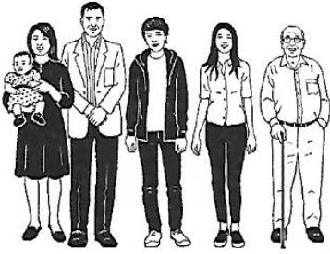
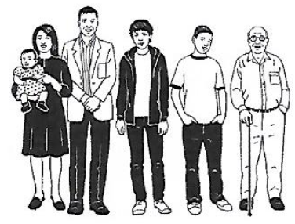
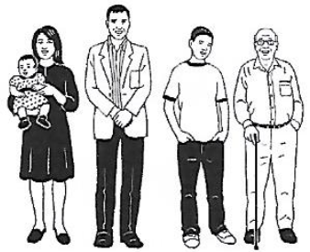

A | B | C

5. What’s the new sports centre next to?

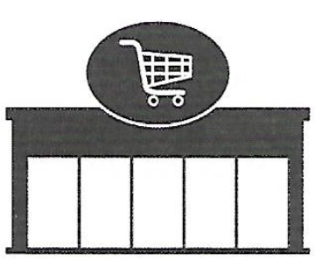
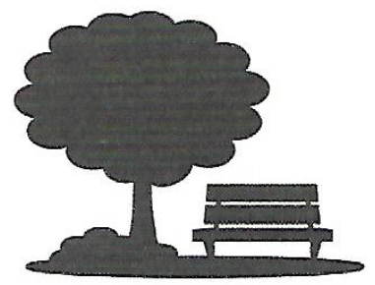

A | B | C

Part 2: Questions 6-10
For each statement, choose T (True) or F (False).

You will hear a girl, Antonia, telling her friend about French lessons.
6. The lessons are at the college. | T / F
7. The lessons are on every Wednesday. | T / F
8. The lessons start at 7:15. | T / F
9. The tuition is £24 per month. | T / F
10. Learners should call the teacher to attend the lessons in October. | T / F

Part 3: Questions 11-15
For each question, choose the correct answer.

11. You will hear Ben talking to his friend about his holiday.
What does Ben still need to pack for his holiday?
A. some winter clothes
B. a good book
C. ski equipment
12. You will hear Lisa telling a friend what she did after college yesterday.
What did Lisa do first?
A. She cooked dinner.
B. She watched television.
C. She did a college project.
13. You will hear David talking to a friend about running.
What’s David’s favourite time of day to go running?
A. in the morning
B. at midday
C. in the evening
14. You will hear Sara talking to a friend about starting university.
What’s Sara going to do in the year before she starts university?
A. get a job
B. read lots of books
C. travel around the world
15. You will hear Jack talking to a friend about playing the guitar.
What advice does Jack give his friend?
A. find a teacher
B. practise every day
C. get a music book for beginners

Part 4: Questions 16-20
For each question, choose the correct answer.

You will hear Tess talking to a friend about the things her family enjoy reading.
What does each person enjoy reading?

Example
0. | Sister | ___D____

People |  |  |  | Things they enjoy reading
16. | Mum | ___ ____ |  | A | adverts
17. | Brother | ___ ____ |  | B | blogs
18. | Dad | ___ ____ |  | C | books
19. | Grandma | ___ ____ |  | D | comics
20. | Cousin | ___ ____ |  | E | emails
 |  |  |  | F | magazines
 |  |  |  | G | newspapers
 |  |  |  | H | text messages

------------------------- Hết -------------------------
Lưu ý: - Đề thi không được sử dụng tài liệu.
- Cán bộ coi thi không giải thích gì thêm.

