TRƯỜNG ĐẠI HỌC CÔNG NGHIỆP
ĐỀ KIỂM TRA THƯỜNG KỲ
ANH VĂN 1 & TIẾNG ANH 1
Môn kiểm tra: Reading
Ngày kiểm tra: ....../ ......./ ......
Thời gian làm bài: 40 phút
(Không kể thời gian phát đề)
THÀNH PHỐ HỒ CHÍ MINH
KHOA NGOẠI NGỮ

Họ & Tên: …………………………………………………. MSSV:…………………………

READING TEST (4 parts): 20 questions

Part 1: Questions 1-5
For each question, choose the correct answer.
1  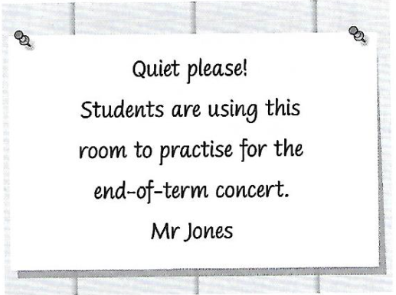 | A. Mr. Jones would like students to practise quietly.  B. Mr. Jones does not want people to talk loudly here.  C. Mr. Jones wants to know which students were noisy.
2  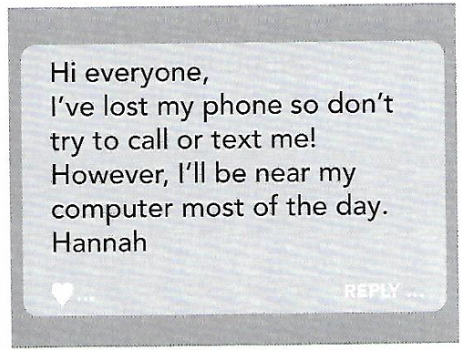 | Why did Hannah write this message?  A. to tell her friends how to contact her  B. to find out if anyone has seen her phone  C. to check if her friends are going out today
3  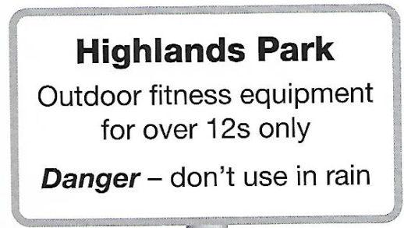 | A. You should not exercise here in wet weather.  B. It’s not safe to use this equipment at the moment.  C. Children under 12 must be with an adult when using this equipment.
4  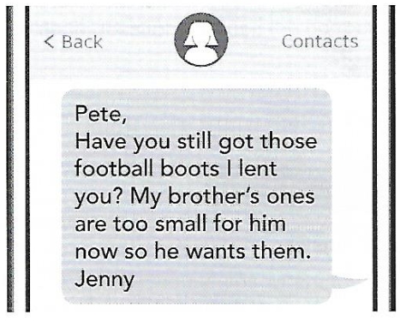 | Jenny is asking Pete to  A. lend her some football boots.  B. return some football boots to her.  C. borrow some boots from his brother.
5   | A. Opening hours will change on May 18th.  B. A big clothes sale begins here on May 18th.  C. It won’t be possible to shop here after May 18th.

Part 2: Questions 6-10
For each question, choose the correct answer.

How important are museums to you?
We asked three young people this question and this is what they told us.
Chris
A lot of my friends think museums are boring but I love them. I prefer ones where they move things round regularly, and bring in new things to keep it interesting. I also like to have things to listen to as well as look at. I suppose I like museums because I'm really interested in history and art. We study these subjects at college, but I've actually found out a lot more about them from museums than from my textbooks.
Emily
I'm lucky because I live in New York, so there are lots of great museums for me to visit. One thing I've learnt is that you should never try to see a whole museum the first time you go. Just go to one or two rooms, and then return as often as you can to see the rest. For me, it's important that the people who work in the museum are pleasant, and happy to talk to me about the things in the exhibition. That makes a big difference.
Daniel
I don't go to museums much, except during my holidays in new cities. Then I make sure I spend at least a day going to the most famous ones. If it's a big museum and I don't have much time, I sometimes walk into a room and choose just five things to look at. I also take a tour if there is one, as I learn so much more from listening to the person showing us round than I do if I'm by myself.

6. Who always visits museums when they travel?
A. Chris
B. Emily
C. Daniel
7. Who says it is important to visit the same museum several times?
A. Chris
B. Emily
C. Daniel
8. Who likes museums where the exhibitions often change?
A. Chris
B. Emily
C. Daniel
9. Who says that museums should have friendly staff?
A. Chris
B. Emily
C. Daniel
10. Who says that they sometimes only look at a few things in a room?
A. Chris
B. Emily
C. Daniel

Part 3: Questions 11-15
For each question, choose the correct answer.
How I spend my free time
Jay Portman describes his unusual hobby, hill running, and tells us why he enjoys it.
Hill running is the sport of running up and down hills and mountains, through open countryside. It's not popular among my friends, but I love it. My dad took me and my brothers out running when we were little, and then when I was about fifteen, I joined a hill running club, called the York Merlins.
There are some excellent runners in the club. When we do our practice runs, I'm always a long way behind them. But that doesn't bother me. They're all really nice and often give me advice. What I love is being outdoors and finding all these beautiful places I never knew were there.
We race against other clubs at the weekends. In these races, runners are told where to finish, but not how to get there. You need a good map and compass so you don't get lost. Everyone starts together at the beginning, but later in the race you often find yourself running alone.
Anyone can enter these races - you just get there in the morning, pay your £5, and run. There are no T-shirts or medals for the winners. The most you get is a piece of cake! Often there are international hill running champions taking part, but they are just as friendly as everyone else.
That doesn't mean it's an easy sport. Last weekend I did a race in heavy rain and high winds, and I was asking myself what I was doing out there. But I got to the end, and that was an amazing feeling.

11. Jay's first experience of hill running was with
A. a club.
B. some friends.
C. his family.
12. How does Jay feel about the good runners in his club?
A. He'd like to be as fast as them one day.
B. He doesn’t mind that they are better than him.
C. He thinks they should help slower runners improve.

13. What does Jay say is important in the races he enters?
A. listening to the instructions
B. staying close to other runners
C. being able to find your way
14. What do we learn about the races from the fourth paragraph?
A. They don't have big prizes.
B. They are only for local runners.
C. They are free for some people to enter.
15. What does Jay say about the last race he did?
A. The bad weather made it dangerous.
B. He was very happy when he finished it.
C. It wasn't as difficult as some races he has done.

Part 4: Questions 16-20
For each question, choose the correct answer.
Dakota Fanning
Dakota Fanning was born on February 23rd, 1994, in Georgia, USA. She began acting classes at a very (16)_____ age and starred in her first TV advert when she was just five years old.
After that, she had a long and successful (17)_____ as a child actor in both TV shows and films. In 2001, she (18)_____ an important prize for her part in the film “I am Sam”. Over the next ten years, she acted with many big Hollywood stars, including Reese Witherspoon, Tom Cruise and Kurt Russell.
Dakota Fanning is different from many child actors because her success continued as she (19)_____ up and became an adult. In 2018, she (20)_____ to TV for the first time in ten years, starring in a popular police drama set in the nineteenth century, called “The Alienist”.
16. | A. | small | B. | early | C. | little
17. | A. | career | B. | job | C. | occupation
18. | A. | did | B. | earned | C. | won
19. | A. | got | B. | grew | C. | went
20. | A. | returned | B. | changed | C. | arrived

------------------------- Hết -------------------------
Lưu ý: - Đề thi không được sử dụng tài liệu.
- Cán bộ coi thi không giải thích gì thêm.

